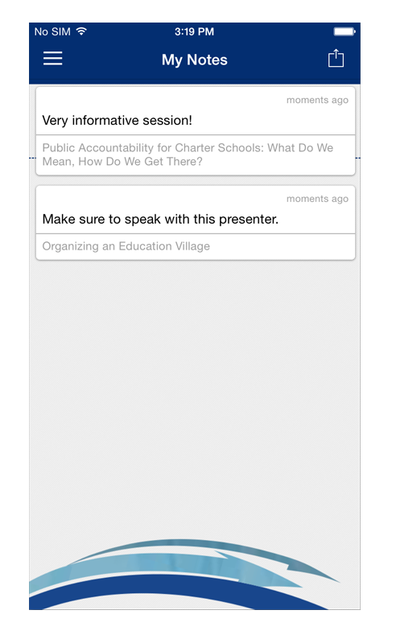
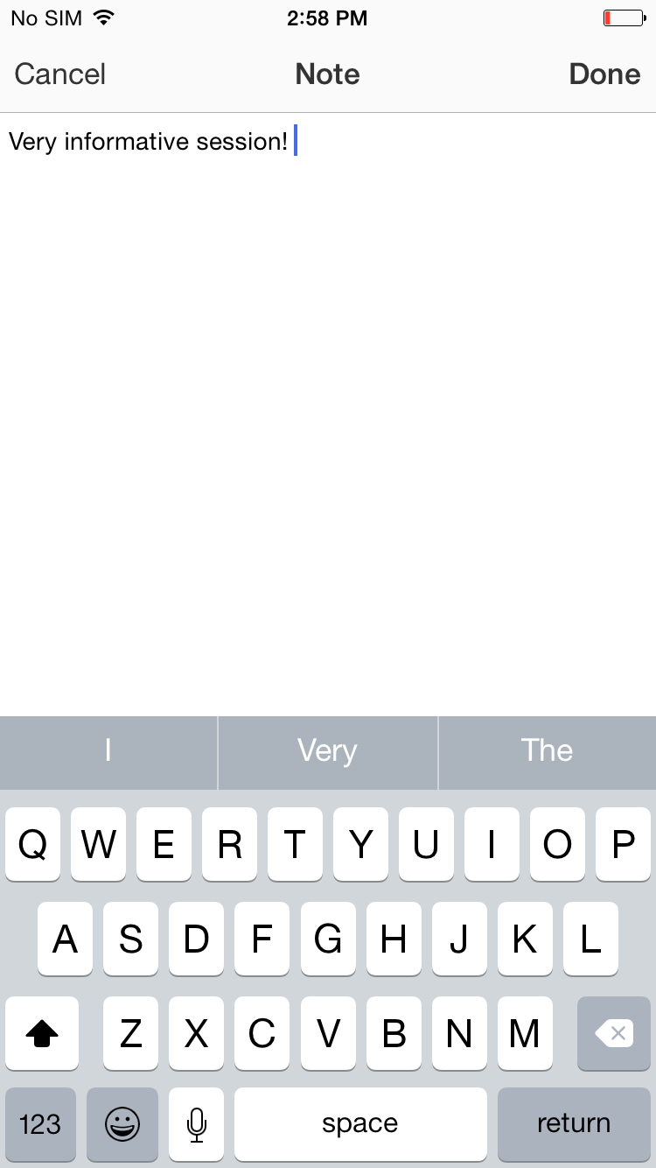
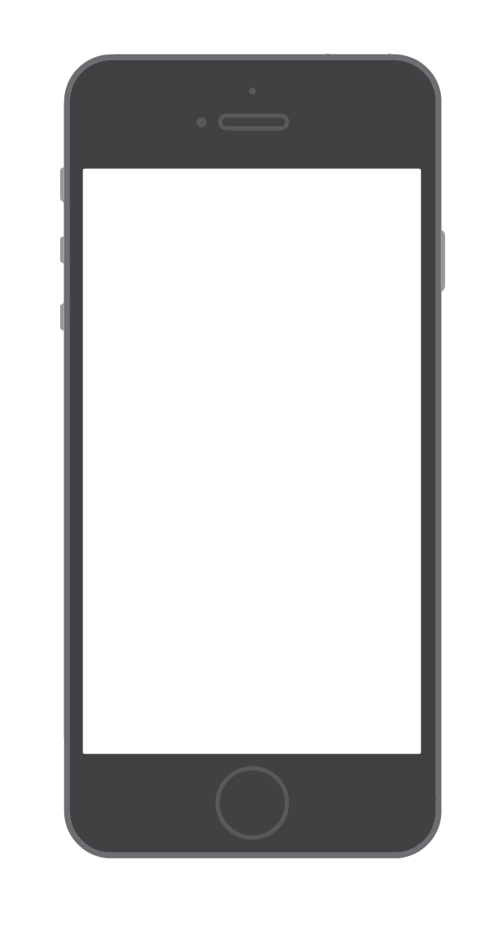
1 Navigate to My Notes. Tap the hamburger icon in the top right, then My Notes.

Here you’ll find all the notes you’ve taken organized by session.
2 Choose where to send your notes. Tap the share icon in the top right and the NORM app will automatically generate a draft of an email that contains all your notes. All you have to do is enter an email address, then tap Send.
Email Them Out
Write Your Thoughts
1 Find your Event Item. After logging in to the NORM Conference app, find the session, speaker or attendee you'd like to create a note about by tapping on the appropriate icon in the Event Directory, then scrolling through the item list.
Once you've found the item you're looking for, tap on it.

2 Write your note. Tap the pencil icon to bring up a blank page and your keyboard. Enter your thoughts, observations and ideas. Tap Done when you've finished.

Creating Notes

