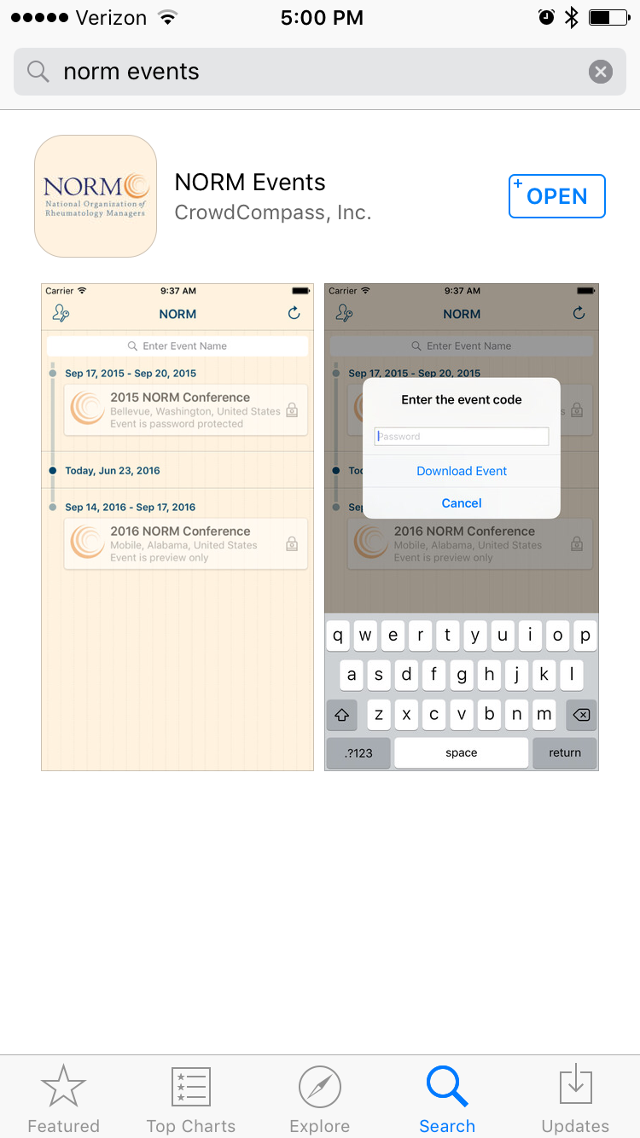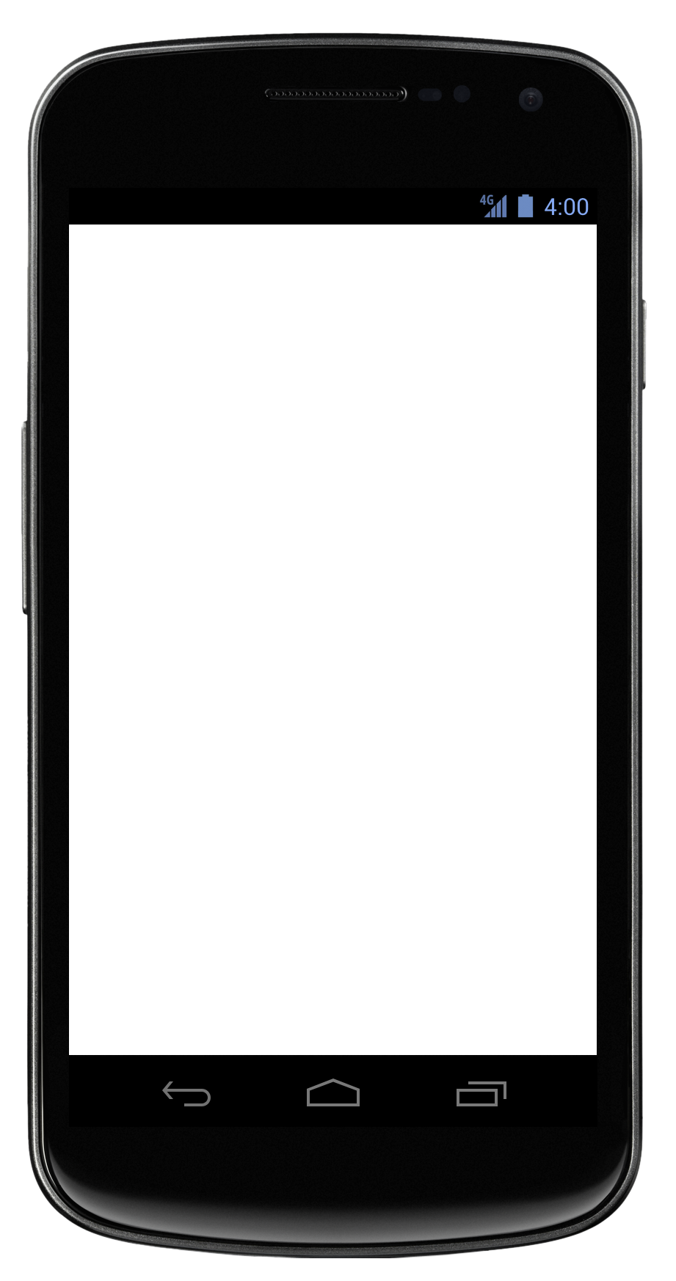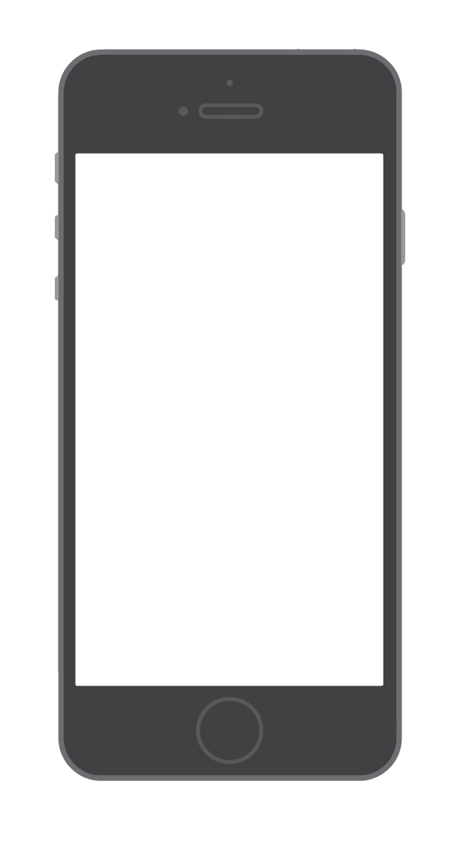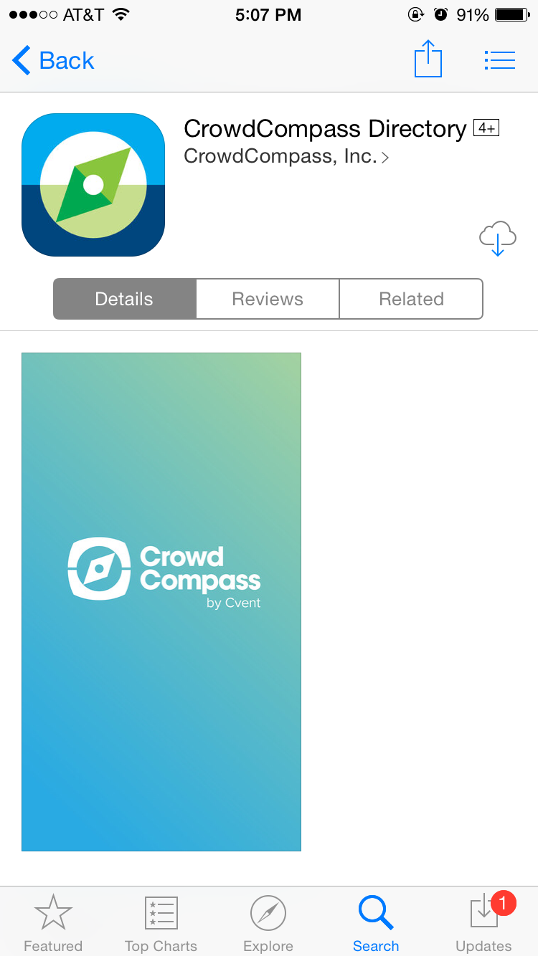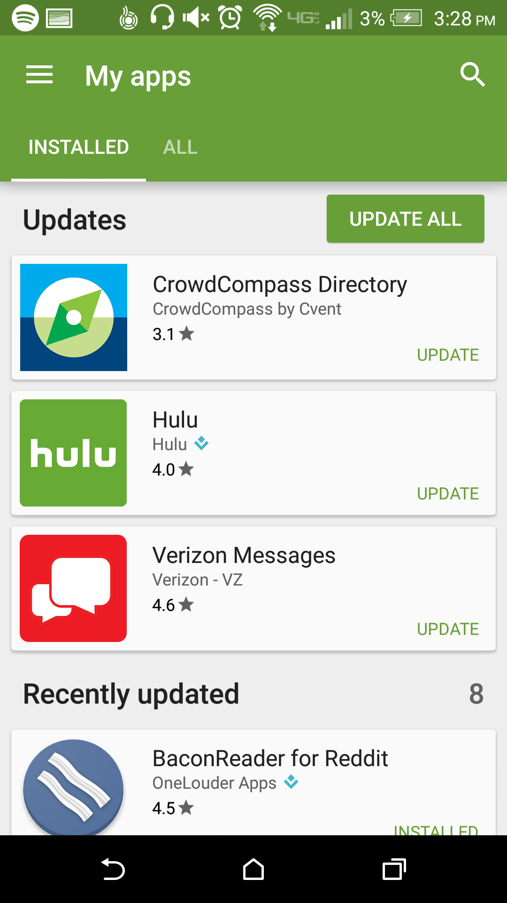

**Downloading the 2016 NORM Conference App**

**Get the app**

**1 Go the right store.** Access the App Store on iOS devices and the Play Store on Android.

*If you’re using a Blackberry or Windows phone, skip these steps.* You’ll need to use the web version of the app instead. <<LINK HERE>>

**2 Install the app.** Search for “norm event.” Once you’ve found the app, tap either **Download** or **Install**.

After installing, a new icon will appear on the homescreen of your phone.

**Or check for updates**

**1 Go to the right store.** Access the App Store on iOS devices and the Play Store on Android.

**2 Check for updates.** If you have an iOS device, tap the **Updates** tab and check the list to see if any updates are available for your app.

For an Android device, tap the hamburger icon, then **My apps**. Check to see if your app is listed under “Updates.” If it is, tap its name, then **Update**.